**OFERTA1**

**CAMARA DLINK DCS-930L=289 SOLES**

**INSTALACION =120 SOLES**

FICHA TECNICA:<http://www.onedirect.es/files/Dlink/DCS-930L_PDF_GB.pdf>

VIDEO: <https://www.youtube.com/watch?v=cI__ePuf0Zs>

[INSTALACION:](https://www.youtube.com/watch?v=cI__ePuf0Zs) <http://www.dlink.com/-/media/Consumer_Products/DCS/DCS%20930L/Manual/DCS_930L_A1_Manual_v1_20_ES.pdf>



**OFERTA2:**

**Nexxt Solutions Nexxt XPY-300= S/.389**

**INSTALACION= 120 SOLES**

FICHA TECNICA:

<http://www.nexxtsolutions.com/pe/downloads/dl/file/id/248/ailr6324u1_xpy_300_ip_camera_specifications_ds_eng_lr_03_21_2012.pdf>

[VIDEO:](http://www.nexxtsolutions.com/pe/downloads/dl/file/id/207/ailr6324u1_xpy_320_ip_camera_specifications_ds_spa_lr_03_07_2012.pdf) <https://www.youtube.com/watch?v=9DVko7JpJR0>

INSTALACION: <https://accvent.desk.com/customer/es/portal/articles/1210022-camaras-ip-configuracion-basica>

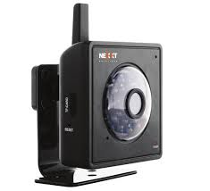

**OFERTA3:**

**Nexxt Solutions Nexxt XPY-320= S/.399**

**INSTALACION= 120 SOLES**

FICHA TECNICA: <http://www.nexxtsolutions.com/pe/downloads/dl/file/id/207/ailr6324u1_xpy_320_ip_camera_specifications_ds_spa_lr_03_07_2012.pdf>

[VIDEO:](http://www.nexxtsolutions.com/pe/downloads/dl/file/id/207/ailr6324u1_xpy_320_ip_camera_specifications_ds_spa_lr_03_07_2012.pdf) <https://www.youtube.com/watch?v=qrVBZ_TCcRA>

INSTALACION: <https://accvent.desk.com/customer/es/portal/articles/1210022-camaras-ip-configuracion-basica>

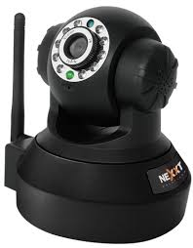

**OFERTA4:**

**Nexxt Solutions - nexxt XPY510 PT=S/.420**

**INSTALACION = 120 SOLES**

VIDEO: <https://www.youtube.com/watch?v=zf5MfgBxLQ4>

FICHA TECNICA: <http://www.nexxtsolutions.com/pe/downloads/dl/file/id/315/xpy_510ds_spa_hr_10_16_2013.pdf>

MANUAL DE INSTALACION: <http://www.nexxtsolutions.com/pe/downloads/dl/file/id/465/xpy_500_510_520_eng_manual_de_usuario.pdf>

